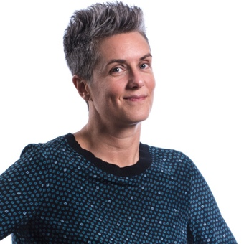

With a background in Chinese Culture, Carlotta is able to bring a deep sense of passion to her 20 years of living and working in China. She is the co-founder of FLATMIND Productions, a boutique video agency with over 15 years of experience in both the Chinese and Western markets.

Carlotta was born in Cesenatico, Emilia Romagna, Italy. Due to her love for unknown cultures and traveling, she decided to pursue a degree in Chinese Language and Culture from the Oriental Languages University of Venice.

In 2003, following her graduation, Carlotta, as a single mother, relocated to Shanghai with her one-and-a-half-year-old son where she by chance started working as an outsourcing consultant for Italian companies producing in China. This job gave her the opportunity to visit China and observe a huge amount of factories and production lines of every kind of product.

Carlotta then met her partner, a film director living in Italy, and together they decided to establish the Chinese branch of his Italian video production company, FLATMIND, in 2008.
FLATMIND has since grown into a distinguished and reliable high-end video agency that works with some of the most prestigious brands across a diverse range of industries.

In addition to her work, Carlotta is passionate about social themes like diversity, women's empowerment, and charity, she’s member of various groups like Shanghai Rotary Club, the Exclusive Executive Business Society and the Int. Professional Women in Shanghai.

With the strong conviction of not wanting to leave the Country and in particular her team, she decided to stay in China for the whole hard time brought by the pandemic. Despite the unprecedent challenges, Carlotta continued to lead FLATMIND with determination and optimism. She embraced the new reality by quickly adapting to remote work and maintaining open lines of communication with her team, clients, and partners. Under her leadership, FLATMIND not only survived but thrived, securing new clients and delivering outstanding work even in the midst of uncertainty.

Looking back at the past year, Carlotta is grateful for the opportunity to grow as a leader and to have such a fantastic team supporting her every step of the way.

