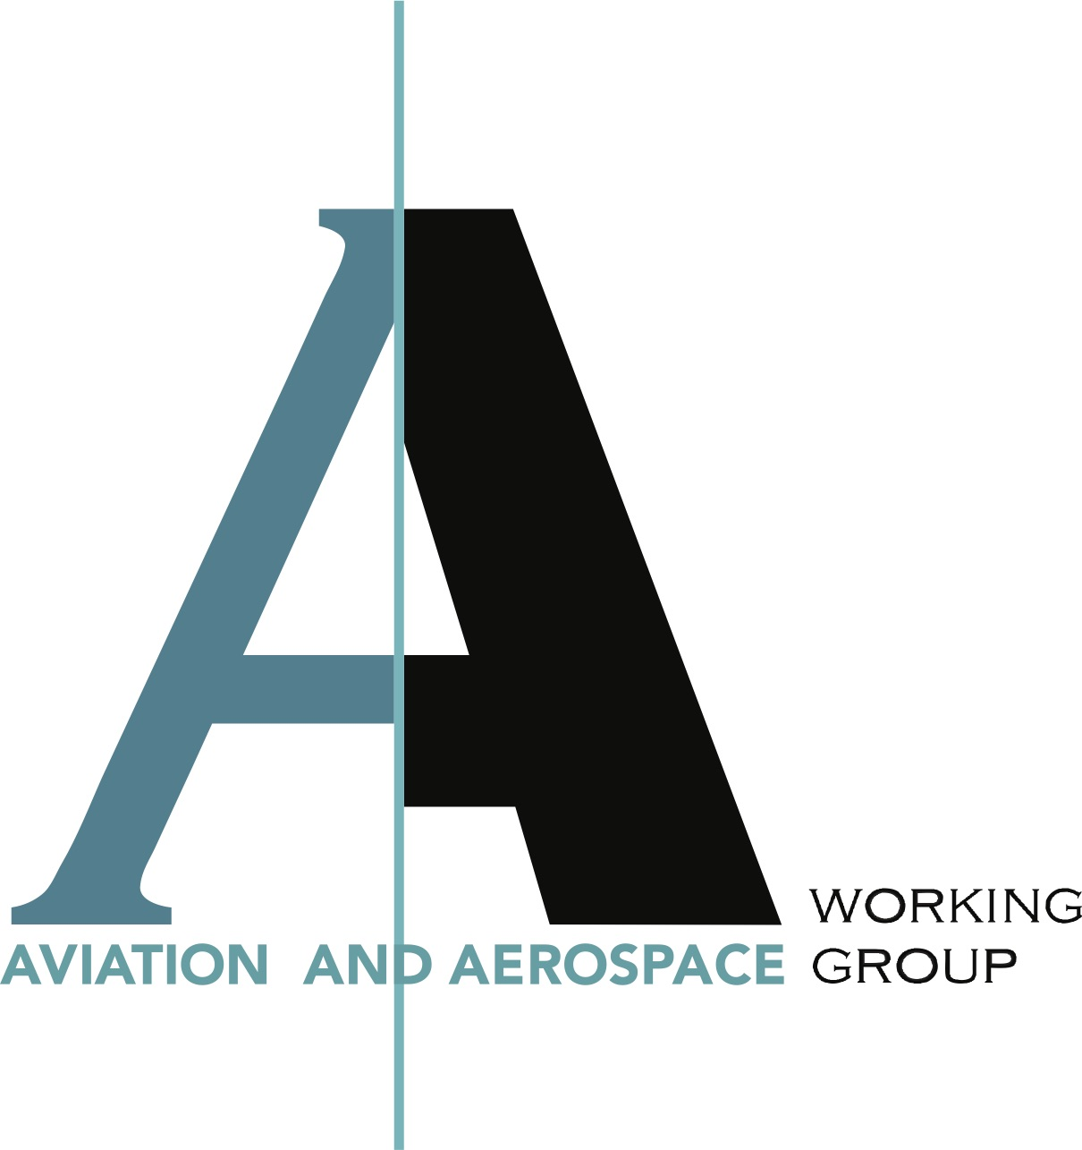
China AirShow 2018

November 6th – 11th 2018

Zhuhai, Guangdong Province

People’s Republic of China

ITALIAN TRADE VISITOR

REGISTRATION FORM (Section A)

Activity Introduction:
Aviation & Aerospace Working Group (AAWG) of China-Italy Chamber of Commerce (CICC) organizes the Italian Pavilion at China AirShow 2018, from November 6th to 11th 2018, in Guangdong Province, China. AAWG CICC invites Italian companies, businessmen, entrepreneurs and managers to visit China AirShow 2018 and to take part to the program: “Italian Trade Visitor”.

What are the benefits of an Italian Trade Visitor?
An Italian Trade Visitor is allowed to enjoy the following benefits: enter China AirShow 2018 venue for one full day, access the Italian Trade Visitors’ Lounge within the Italian Pavilion, meet 4/5 selected potential Chinese clients and partners, visit the static and dynamic aircrafts’ displays, visit acrobatic air-shows, enjoy coffee and refreshments. The cost to participate in the program “Italian Trade Visitor” is €500,00 per company, available on November 6th, 7th, 8th and 9th, 2018. Please fill in the Registration Form - Section B, if interested.

Why is the China AirShow so important?
China AirShow 2018 is the only international aviation and aerospace trade show approved by the State Council that takes place every two years in Zhuhai, Guangdong Province, People’s Republic of China, since 1996. It is the most important gateway for international aviation and aerospace enterprises to showcase the latest technology and products in the fast-growing Chinese market, meet potential clients and find new partners.

What about the Aviation & Aerospace Working Group (AAWG) of China-Italy Chamber of Commerce (CICC)?
AAWG CICC represents the interests of Italian companies operating within the aviation and aerospace industry in China. It is coordinated by aviation and aerospace professionals to: lobby with Chinese counterparts on behalf of Italian member companies, bring the voice of Italian companies to the attention of bi-lateral round-tables, present the Italian know-how to Chinese potential clients and partners, and listen to the needs of Chinese counter-parts involved in developing new civil and general aviation projects. AAWG members operate within the following sectors: fixed wing aircraft, rotary wing aircraft, propulsion, software, components, design and assembly of parts, metallurgy, mechanics, electro-mechanics, electronics, manufacturing and processing of plastics, rubber and all high-performance materials for complex applications, airport design, engineering and architecture.

China AirShow 2018

November 6th – 11th 2018

Zhuhai, Guangdong Province

People’s Republic of China

ITALIAN TRADE VISITOR

REGISTRATION FORM (Section B)

COMPANY INFO:
Company Name
Company Address
Company Web-Site
Contact Name
Contact E-Mail Address
Contact Phone Number
CICC Member? | YES NO

Yes, our Company is interested to participate in the program “Italian Trade Visitor” at China AirShow 2018, on one of the following date, at the cost of € 500,00:
November 6th 2018
November 7th 2018
November 8th 2018
November 9th 2018

Name Surname Position Signature

_______________________ _______________________ ______________________

Date (dd/mm/yyyy)

/ /

